**Profit Tracker App Project Documentation**

**Group 8**

**APT2080 Introduction to Software Engineering**

**Fall 2024**

Contents

1.0 Project Description 3

2.0 Project Overview 3

1.2 Project Objectives 4

1.3 Project Scope 4

Scope Covered 4

Out of Scope 6

3.0 System 7

Work Break Down Structure 7

Project Budget and Estimations 7

Project Sample Screenshots 8

## 1.0 Project Description

The Profit Tracker is a comprehensive application designed to manage users, products, and transactions within a business environment. It provides a graphical user interface (GUI) built using Tkinter, allowing users to perform various operations such as creating, viewing, updating, and deleting records related to users, products, and transactions. The application uses SQLite databases to store and manage data.

## 2.0 Project Overview

**Profit Tracker**

**Key Features:**

1. User Management:

2. Product Management:

3. Transaction Management:

4. Login System:

5. Database Initialization:

**Technologies Used:**

Python: The primary programming language used for developing the application.

Tkinter: A standard GUI library for Python, used to create the graphical user interface.

SQLite: A lightweight, disk-based database used to store user, product, and transaction data.

Hashlib: A library used for secure hashing of image file names.

Shutil: A library used for high-level file operations, such as copying image files.

**File Structure:**

user.py: Contains the `User` class and methods for managing user data.

product.py: Contains the `Product` class and methods for managing product data.

transaction.py: Contains the `Transaction` class and methods for managing transaction data.

main.py: The main entry point of the application, handling the GUI and integrating the different modules.

## 1.2 Project Objectives

The primary objectives of the Profit Tracker project are to develop a comprehensive profit tracking application that efficiently manages users, products, and transactions within a small business environment. The key objectives include:

1. User Management

Create and Manage Users Enable administrators to add, view, update, and delete user records, ensuring that all relevant user information is accurately maintained.

User Authentication Implement a secure login system to authenticate users and control access to the application.

1. Product Management

Inventory Control Allow users to add, view, update, and delete product records, ensuring that the inventory is accurately tracked.

Product Information Store detailed information about each product, including images, to facilitate easy identification and management.

1. Transaction Management

Record Transactions Enable users to record new transactions, including details such as employee ID, product ID, quantity, price, and timestamp.

Transaction History Provide a comprehensive view of all transactions, allowing users to track sales and generate reports.

1. Data Integrity and Security

Data Storage Use SQLite databases to store user, product, and transaction data securely.

Data Encryption Implement encryption for sensitive data, such as passwords and image file names, to ensure data security.

1. User-friendly Interface

Intuitive Design Develop a user-friendly graphical user interface (GUI) using Tkinter, making it easy for users to navigate and perform various operations.

Usability Ensure that the application is accessible and usable by all intended users, including those with varying levels of technical expertise.

## 1.3 Project Scope

### Scope Covered

The scope of the Profit Tracker project includes the development, implementation, and maintenance of a comprehensive application for managing users, products, and transactions. The project will cover the following areas.

1. **User Management Module**

Features

Create, view, update, and delete user records.

Secure user authentication and authorization.

Components

User interface for user management.

Database for storing user information.

Authentication mechanisms.

1. **Product Management Module**

Features

Create, view, update, and delete product records.

Store detailed product information, including images.

Components

User interface for product management.

Database for storing product information.

Image storage and management.

1. **Transaction Management Module**

Features

Create, view, update, and delete transaction records.

Generate reports and summaries of transactions.

Components

User interface for transaction management.

Database for storing transaction information.

Reporting tools.

1. **Database Management**

Features

Uses SQLite databases to store user, product, and transaction data.

Components

Database schema design.

1. **User Interface Design**

Features

Develop a user-friendly GUI using Tkinter.

Ensures intuitive navigation and usability.

Components

Wireframes and mock-ups of the user interface.

User interface components (buttons, text fields, list boxes, etc.).

### Out of Scope

The following areas are considered out of scope for the Profit Tracker project

1. Advanced Reporting and Analytics
2. Integration with External Systems

The project will not include integration with external systems, such as ERP systems or third-party applications.

1. Mobile Application

The project will not include the development of a mobile application. The focus will be on the desktop application using Tkinter.

1. Ecommerce Functionality

The project will not include ecommerce functionality, such as online ordering or payment processing.

## 3.0 System

### Work Break Down Structure

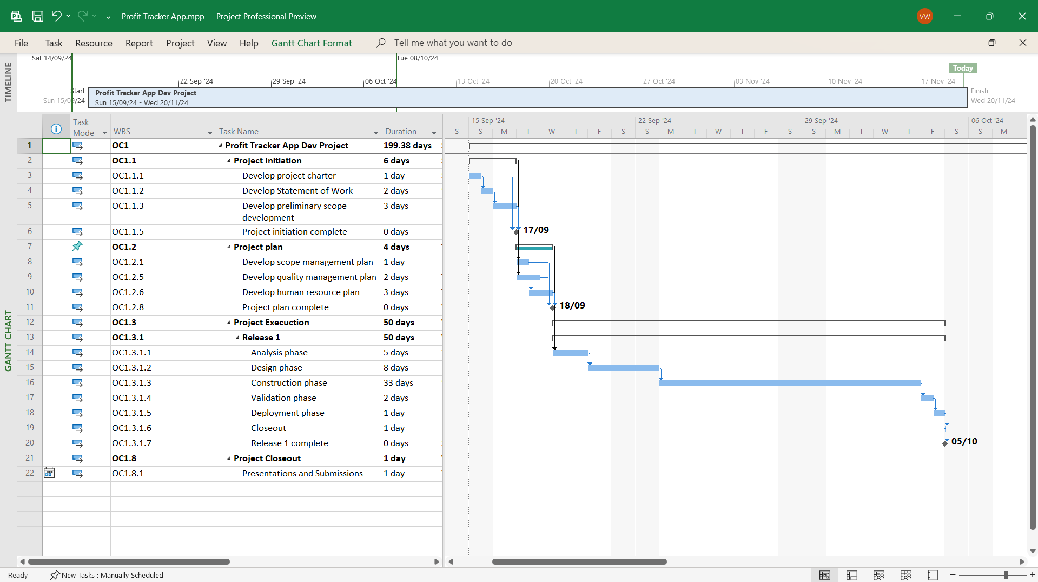

### Project Budget and Estimations

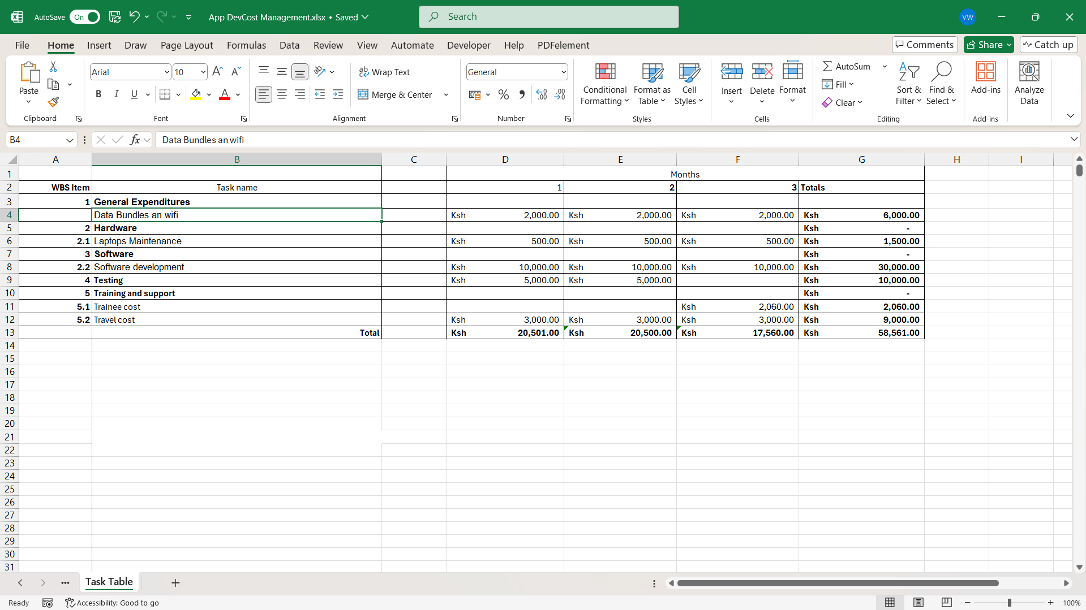

### Project Sample Screenshots

